CALDER AGENTIC AI ENGINEERING WEEK 3 REPORT

- WEEK 3 CONCEPTS
Embedding: An embedding is a numerical vector representation of text that captures its meaning. Similar concepts have similar vectors placed close together in vector space.
Cosine Similarity: Cosine similarity measures how similar two vectors are by calculating the angle between them.
Values:
1.0: Very similar (same direction)
0.0: Not similar (perpendicular)
-1.0: Opposite (opposite direction)
Dimensionality: Dimensionality refers to the number of values in a vector representation.
Why Dimensionality Matters:
- More dimensions = More information captured
- More dimensions = More storage required
- More dimensions = Slower computation

Vector Database: A specialized database designed to store and search vectors efficiently. It finds the most similar vectors to your query.
i- ChromaDB
Features:
- In-memory or persistent storage
- Metadata filtering
- Easy integration with LangChain
ii- FAISS (Facebook AI Similarity Search)
Features:
- In-process (no server required)
- Very fast
- GPU acceleration support

RAG: RAG stands for Retrieval-Augmented Generation. It retrieves relevant documents and uses them as context for the LLM to generate better answers.
Naive RAG Pipeline
INGESTION PHASE:
1. Load Documents
2. Split into Chunks
3. Create Embeddings
4. Store in Vector Database

QUERY PHASE:
5. User Asks Question
6. Embed Question
7. Retrieve Relevant Chunks
8. Send to LLM with Context
9. Generate Response
Text Splitting (Chunking): Dividing documents into smaller pieces called chunks.
Advanced Retrieval:
i- Hybrid Search
Combining keyword-based search (BM25) with semantic search.
Why Hybrid:
- Keywords catch exact matches
- Semantics catch meaning-based matches
- Better overall coverage

ii- BM25 (Best Matching 25)
A ranking function for keyword search based on term frequency and inverse document frequency.
iii- EnsembleRetriever
Combines multiple retrievers and returns results from both.
iv- Cross-Encoder Re-ranking
A model that takes a query and a document together and scores their relevance directly.
v- HyDE (Hypothetical Document Embeddings)
Generates a hypothetical document that would answer the question, then uses that document's embedding for retrieval.
vi- Multi-Query Retrieval
Generates multiple variations of the user's question and retrieves for each.

RAG Evaluation:
RAGAS Metrics
RAGAS is a framework for evaluating RAG systems without human labels.
1. Faithfulness
Whether the generated answer is factually supported by the retrieved context.
2. Answer Relevancy
Whether the answer directly addresses the question.
3. Context Precision
Whether the retrieved chunks are actually relevant to the question.
4. Context Recall
Whether the retrieved chunks contain all information needed to answer.

- INTERMEDIATE PROJECT
I have chosen option C as my intermediate project (Hybrid search engine).
- System architecture
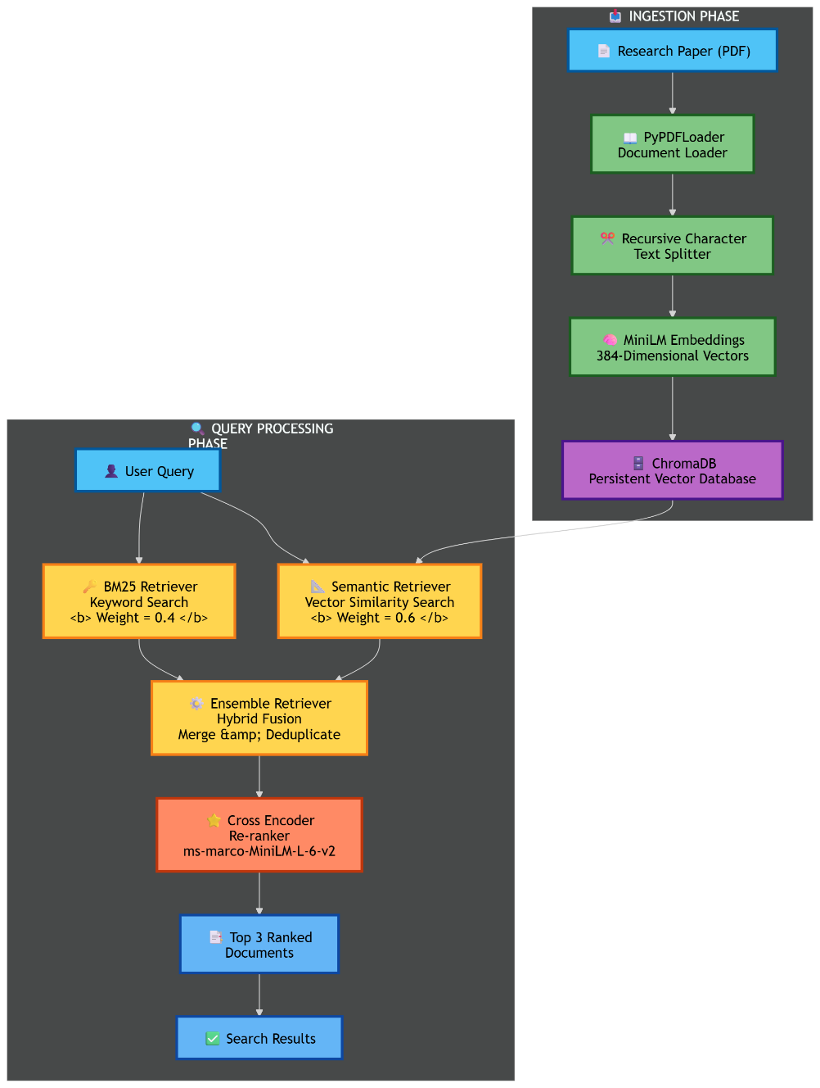

- Technology stack

Component | Technology | Purpose
Document Loader | PyPDFLoader | Load PDF documents
Text Splitter | RecursiveCharacterTextSplitter | Split into 512-token chunks with 50-token overlap
Embedding Model | all-MiniLM-L6-v2 | Convert text to 384-dim vectors
Vector Database | ChromaDB | Store and query embeddings
Keyword Search | BM25Retriever | Exact keyword matching
Hybrid Retriever | EnsembleRetriever | Combine BM25 + Semantic
Re-ranker | Cross-Encoder (ms-marco-MiniLM-L-6-v2) | Deep relevance scoring
Evaluation | Custom metrics | Context Precision, Answer Relevancy

- Week 3 concepts applied:
Concept: Sentence-Transformer Embeddings
Every document chunk is converted into a 384-dimensional embedding vector using the all-MiniLM-L6-v2 model.
Concept: ChromaDB Storage + Document Chunking
Documents are split into 512-character chunks with 50-character overlap, then stored in ChromaDB with metadata.

Concept: Full RAG Pipeline
Pipeline Steps:
Load → Split → Embed → Store → Retrieve → Generate

Concept: Hybrid Search (BM25 + Semantic)
Combines BM25 keyword search with semantic retrieval using EnsembleRetriever.

Concept: Cross-Encoder Re-ranking
After initial retrieval, a cross-encoder (ms-marco-MiniLM-L-6-v2) re-ranks the results for deeper relevance scoring.

Concept: Evaluation Metrics
Measures whether retrieved chunks are relevant to the query.

- Error handling and fault tolerance
1. Missing or Corrupted PDF (Step 1 & 2):
Scenario: PDF fails to download or is corrupted
Action: Pipeline catches HTTP/IO error and immediately aborts
2. Chunking Failure (Step 3):
Scenario: PDF loaded but 0 chunks produced (e.g., image-only PDF)
Action: Pipeline detects 0 chunks and raises PipelineError
3. Embedding Model Failure (Step 4):
Scenario: HuggingFace Hub is down or offline
Action: Exception is caught, pipeline halts safely
4. Vector Store Failure (Step 5):
Scenario: Read/Write permission error on disk
Action: Caught and aborted safely

- Features & Screenshots

Feature 1: PDF Download & Processing
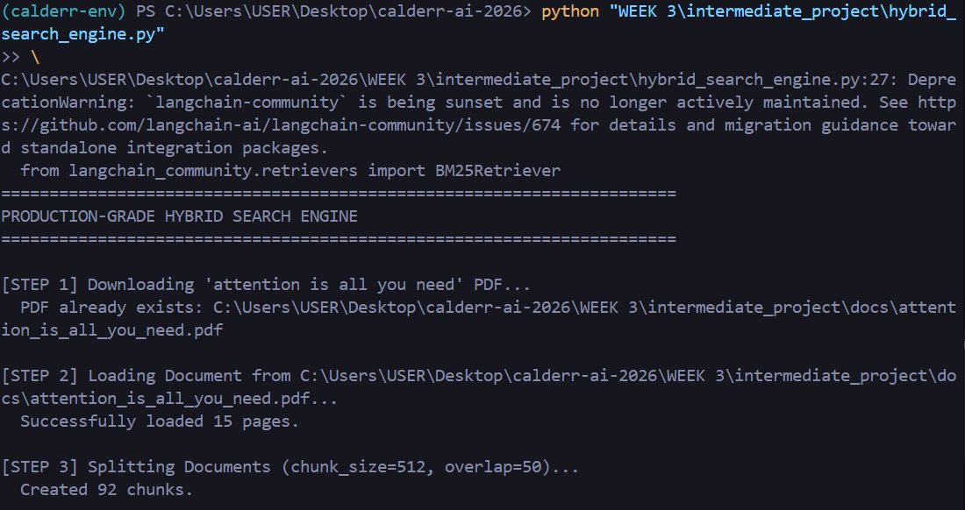

Feature 2: Hybrid Retriever Construction
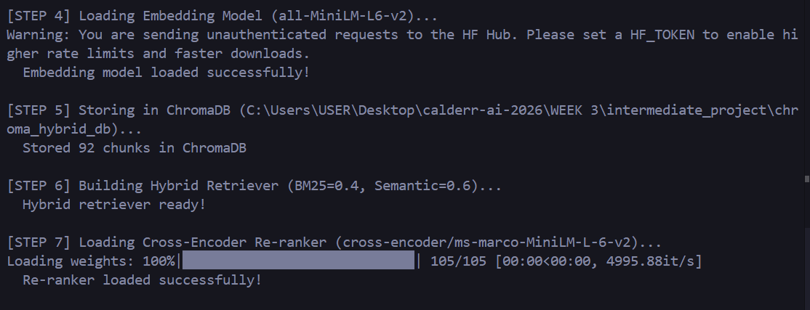

Feature 3: Evaluation on "Attention Is All You Need" Paper
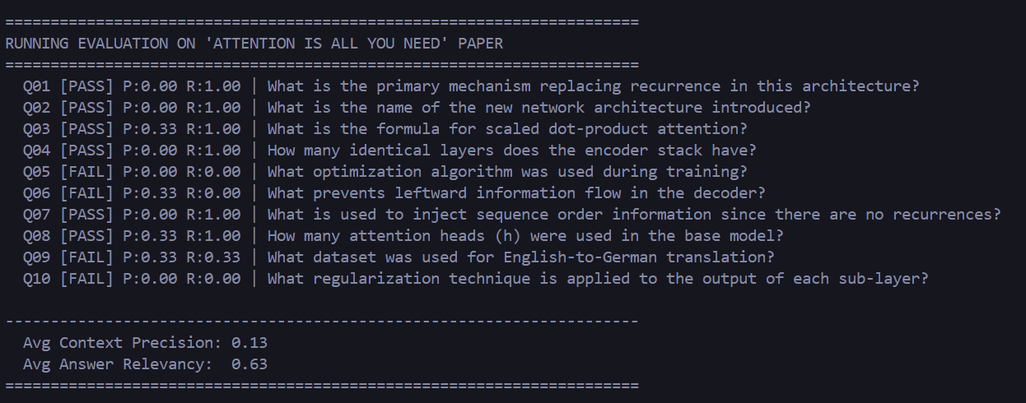

Feature 4: Interactive Search

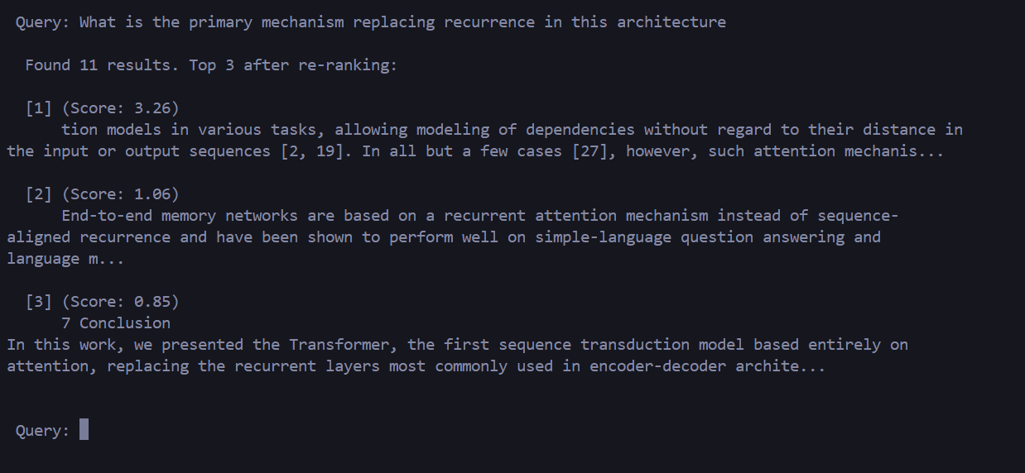

- PRODUCTION PROJECT
I have choosen option 3-p-c for my production project (RAG Evaluation Benchmark).
Option C include:
- Systematic testing across 6 configurations
- Statistical comparison of results
- Publishable report generation
- Reusable framework for future projects
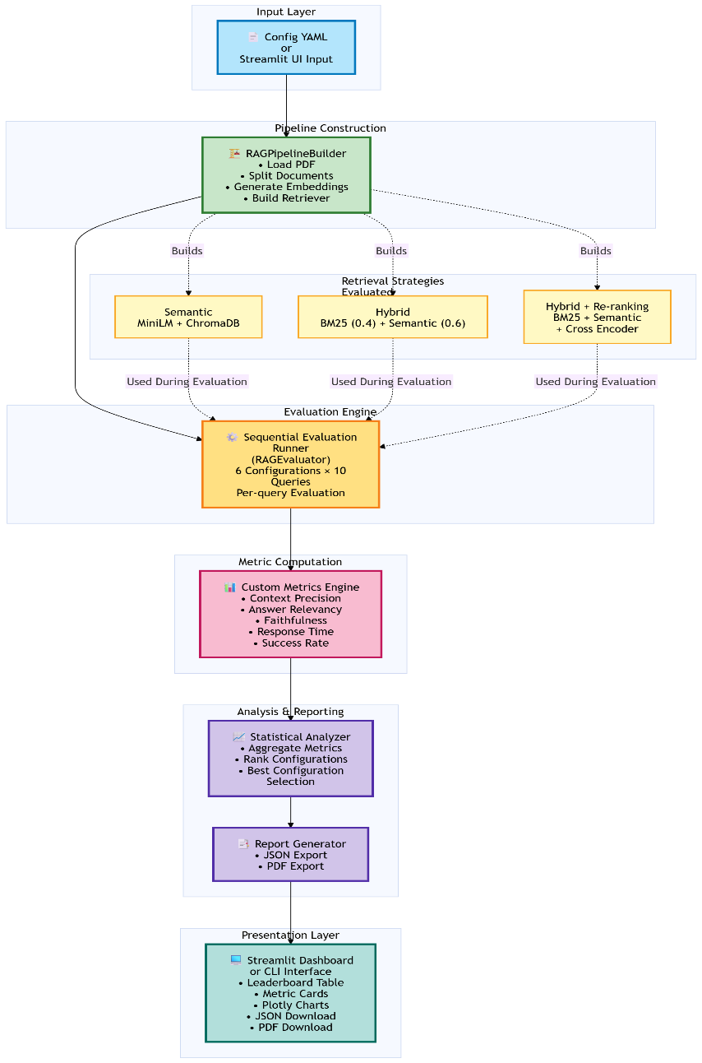
i- System architecture

ii- Technology Stack

Component | Technology | Purpose
Document Loader | PyPDFLoader | Load PDF documents
Text Splitter | RecursiveCharacterTextSplitter | Split into configurable chunks
Embedding Model | all-MiniLM-L6-v2 | Convert text to 384-dim vectors
Vector Database | ChromaDB | Store embeddings per config
Keyword Search | BM25Retriever | Exact keyword matching (weight: 0.4)
Semantic Search | ChromaDB Retriever | Meaning-based matching (weight: 0.6)
Hybrid Retriever | EnsembleRetriever | Combine BM25 + Semantic
Re-ranker | Cross-Encoder (ms-marco-MiniLM-L-6-v2) | Deep relevance scoring
UI Framework | Streamlit | Interactive dashboard
Visualization | Plotly | Charts and graphs
Data Processing | Pandas | Data manipulation
Evaluation | Custom Metrics | Context Precision, Answer Relevancy, Faithfulness

iii- Week 3 concepts applied

Concept: Sentence-Transformer Embeddings (all-MiniLM-L6-v2)
Every document chunk is converted into a 384-dimensional embedding vector for semantic retrieval.

Concept: ChromaDB Storage & Document Chunking
Tested with multiple chunk sizes (512/50, 1024/100) and stored in ChromaDB with collection-per-config isolation.

Concept: Full RAG Pipeline
Pipeline Steps:
Load → Split → Embed → Store → Retrieve → Evaluate

Concept: Hybrid Search (BM25 + Semantic)
Combines BM25 keyword search with semantic retrieval using EnsembleRetriever.

Concept: Cross-Encoder Re-ranking
After initial retrieval, a cross-encoder re-ranks results for deeper relevance scoring.

Concept: RAGAS Metrics (Custom Implementation)
1. Context Precision
Measures whether retrieved chunks are relevant to the query.
2. Answer Relevancy
Measures whether retrieved content actually answers the question.
3. Faithfulness
Measures whether the answer is factually supported by the context.

iv- Error handling & Fault tolerance

1. Missing or Corrupted PDF:
Scenario: PDF fails to download or is corrupted
Action: Pipeline catches HTTP/IO error and immediately aborts
2. Chunking Failure:
Scenario: PDF loaded but 0 chunks produced (image-only PDF)
Action: Pipeline detects 0 chunks and raises PipelineError
3. Embedding Model Failure:
Scenario: HuggingFace Hub is down or model name invalid
Action: Exception caught, pipeline halts safely
4. Vector Store Failure:
Scenario: Read/Write permission error on disk
Action: Caught and aborted safely
5. Unknown Retrieval Strategy:
Scenario: Config has unrecognized retrieval_strategy value
Action: PipelineError raised with descriptive message
6. Per-Query Failures (Graceful Degradation):
Scenario: Single evaluation query fails (LLM timeout)
Action: Error logged, query skipped, evaluation continues

V- Features & Screenshots

Feature 1: CLI Benchmark Mode
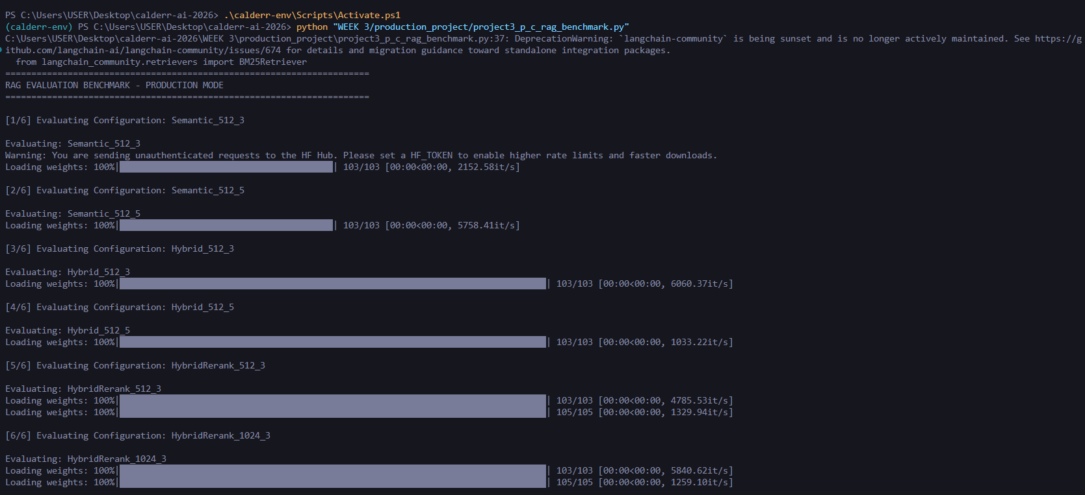
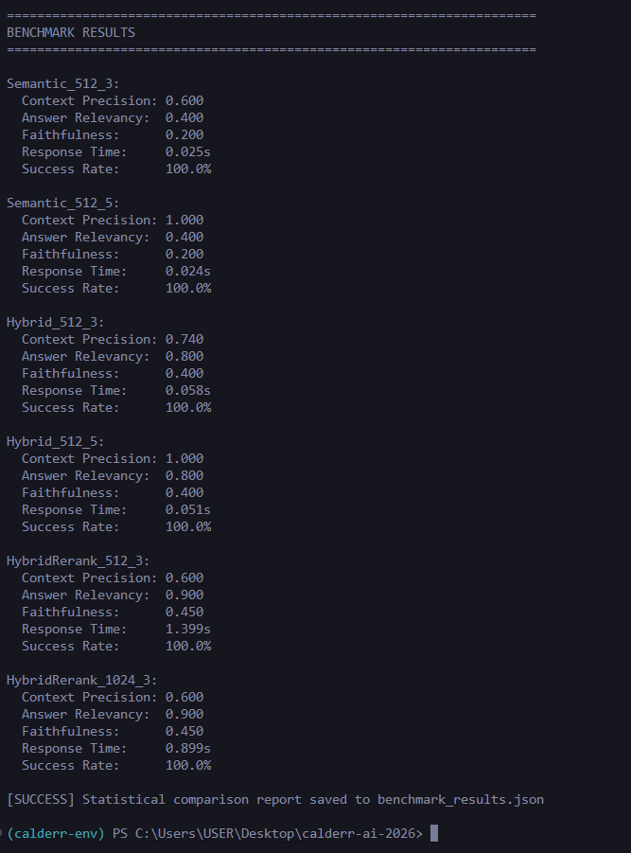
Feature 2: Streamlit Dashboard
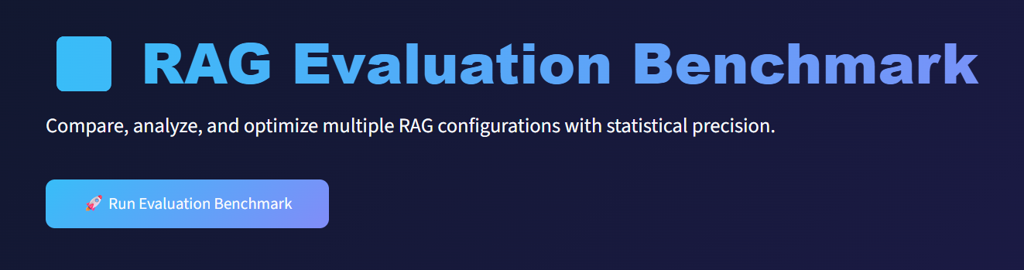

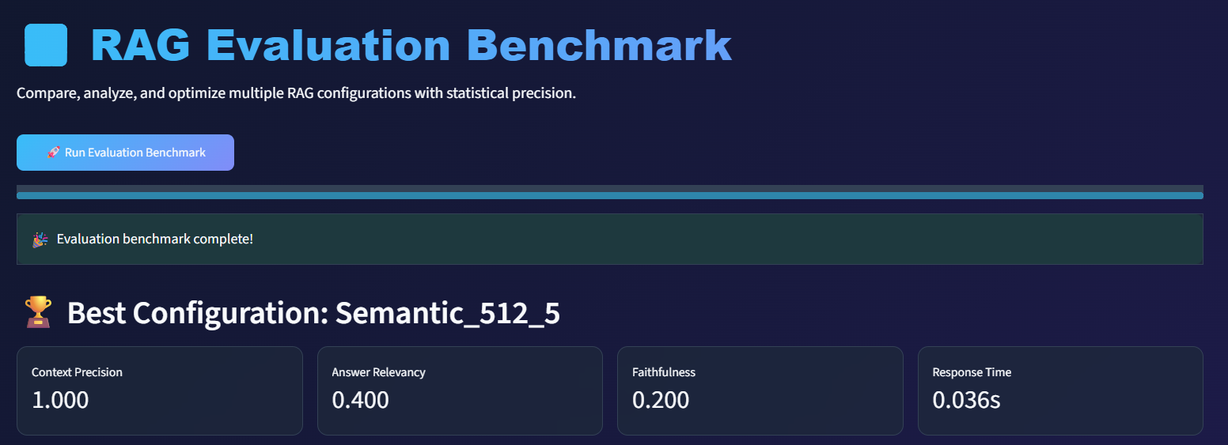
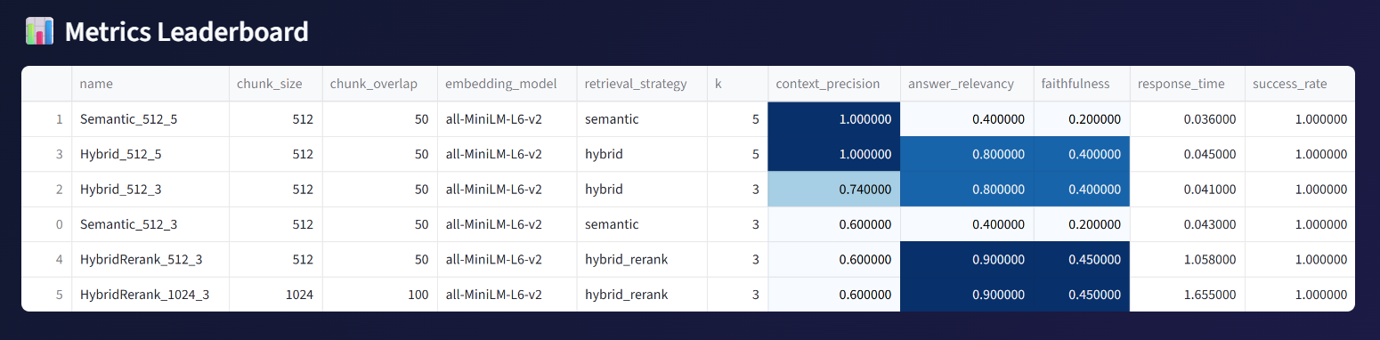
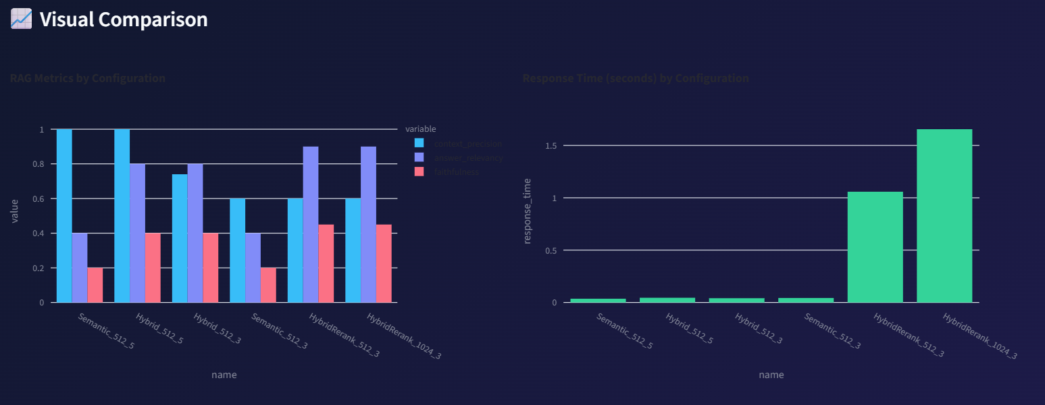
Feature 4: Report Export

- PDF report
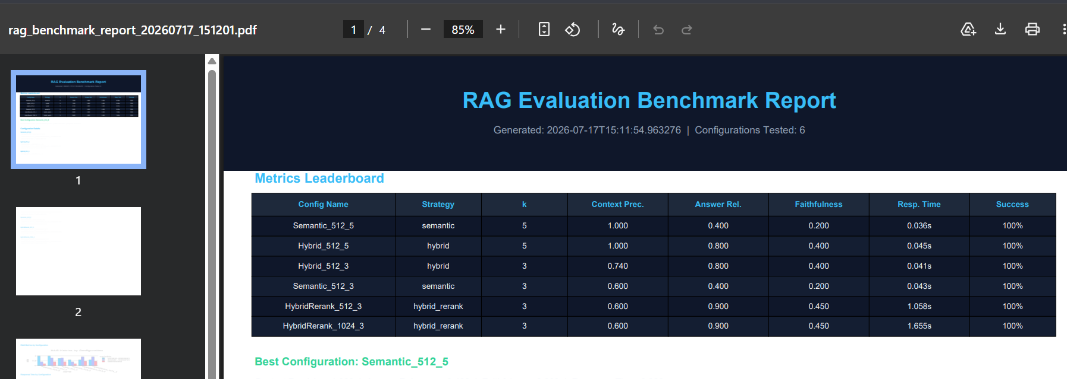

- JSON report
